**Chapter 4**

**Results and Analysis**

**4.1 Introduction**

This chapter presents a comprehensive analysis of the experimental results obtained from applying the bespoke behavioral analysis framework and the developed classification model for ransomware detection. We delve into the intricacies of the dataset used, the feature engineering process, the model development, and subsequent evaluation. Through a lens of critical analysis, we explore the model's robustness, its generalization capabilities, and the ethical considerations that guided its deployment.

**4.2 Dataset Description**

Within this segment, we embark on an extensive exploration of the dataset that forms the cornerstone of our experimentation in the realm of AI-driven ransomware detection. This dataset, meticulously curated through the meticulous analysis of various software within the controlled environment of Google Sandbox, emerges as the foundational bedrock upon which both our proposed behavioral analysis framework and classification model are meticulously crafted, evaluated, and refined. This comprehensive exposition not only illuminates the dataset's origins and dimensions but also delves into its inherent characteristics and the meticulous preprocessing it underwent, all in preparation for the profound analytical journey that follows. The genesis of this dataset lies in the careful curation resulting from comprehensive analyses conducted on a diverse spectrum of software samples. Culled from a multitude of sources, these samples converge to paint a panoramic portrait of software behaviors that encapsulate a holistic understanding. As rows within the dataset mirror individual software instances, the columns house an array of attributes meticulously chosen to meticulously encapsulate the behavioral dynamics of the software. These attributes span a gamut of interactions encompassing the realm of file operations, network communications, registry maneuvers, API invocations, and more. Also, Size and Granularity were also considered in the choice of the dataset. Anchored in its voluminous nature, the dataset hosts a substantial number of distinct software samples, thus creating a fertile ground for profound analysis. This magnitude is pivotal, as it grants us the capacity to engage in the rigorous scrutiny essential for unraveling the intricate behavioral nuances that define diverse software categories. The ample expanse of this dataset not only accommodates a multitude of behavioral profiles but also empowers us to distill subtle variances inherent in varying software behaviors.

Akin to a multifaceted tapestry, the dataset unfurls a panorama of software behaviors spanning the continuum from benign to potentially malicious. This mosaic of behaviors serves as a reflective microcosm of the intricacies encountered within real-world contexts. Encompassing a spectrum of implications, the dataset inherently encapsulates attributes that lay bare interactions within the domains of files, network resources, the Windows registry, API invocations, and beyond. As the dataset embarked on its journey toward meaningful analysis, it traversed the meticulous realm of preprocessing. This phase is instrumental, bestowing integrity and value upon the dataset. Within this phase, data cleansing maneuvers eradicated inconsistencies, while measures to mitigate the impact of missing values were carefully orchestrated to preserve coherence. Furthermore, normalization, a standardization process, was invoked to render the attributes homogenous across distinct scales. The vigilance extended to outliers, those potential distortions, which underwent judicious examination and rectification.

A pivotal transformation was the conversion of categorical attributes into their numerical equivalents. This metamorphosis was instrumental in aligning the dataset with the realm of machine learning, enabling seamless interaction with algorithms grounded in numerical inputs. Consequentially, this transformation unveiled insights that enrich ransomware detection efforts. Moreover, a crucial juncture involved feature engineering, whereby pertinent behavioral attributes indicative of ransomware activities were meticulously distilled and curated. Also, Acknowledging the variability in attribute ranges, normalization, and scaling surfaced as pivotal players in ushering all attributes onto a shared scale. This strategic orchestration thwarted the disproportionate sway attributed to individual attribute scales, ensuring a level of analytical playing field wherein each attribute's contribution is equitable.

A vigilant commitment to the dataset's integrity and consistency underscored the entire analytical endeavor. The stringent regimen of validation ensured the dataset's resilience against inaccuracies, cementing its status as a reliable repository of software behavior profiles. This unwavering dedication to preserving the dataset's integrity not only serves as a testament to our rigorous methodology but also underpins the reliability of our subsequent analyses, suffusing our journey with unwavering credibility and relevance.

**4.3 Feature Engineering and Selection**

At the core of our Analysis lies the intricate process of feature engineering and selection, a crucial phase that elevates our analysis by refining the attributes within the dataset to unveil nuanced insights. This transformative journey involves extracting and curating behavioral features that hold intrinsic significance in the context of ransomware detection. However, this is no mechanical endeavor; rather, it's an exercise in discernment, guided by the complexities of software behaviors and the specific objectives of our analysis. Behavioral Feature Extraction becomes the conduit through which the essence of feature engineering manifests. This phase involves the translation of a diverse array of software actions—ranging from file interactions and network communications to registry manipulations and API invocations—into numerical representations. This metamorphosis weaves these varied actions into a cohesive narrative of behavioral attributes, rendering them amenable for integration into the fabric of machine learning frameworks. The rationale behind the selection of specific features is deeply rooted in their inherent ability to characterize ransomware behaviors. Each chosen attribute serves a unique purpose in revealing the underlying patterns and interactions that define software profiles. For example, the observation of file access patterns offers a glimpse into the calculated maneuvers of ransomware attempting to systematically encrypt vital files. Similarly, the scrutiny of network communication patterns unveils the intricate choreography of command-and-control interactions that often underpin ransomware orchestrations. The driving force behind these selections lies in their capacity to detect deviations from legitimate behaviors, making them indicative of potential ransomware activities. However, these selected features are not isolated entities; they carry with them a rich contextual interpretation. Their significance extends beyond surface-level extraction, diving deep into the insights they provide about software behavior. This contextual understanding informs our analysis, enabling the deciphering of behavioral patterns that underlie a spectrum of software categories. Moreover, the relevance of these selected features to ransomware detection is a defining characteristic. They are not arbitrarily chosen; rather, they are meticulously curated to address the very heart of ransomware detection challenges. These attributes act as guiding lights, directing our AI model to discern the subtle yet crucial signatures that mark ransomware behaviors. Their significance transcends individual actions; they collectively weave a narrative of interactions that mirrors the intricate dance of software in various scenarios. This systematic grouping strategy enhances the granularity and efficacy of subsequent analysis and modeling, particularly in the context of AI-driven ransomware detection. Let's delve deeper into each categorized feature group to unveil a more intricate and comprehensive understanding of the dataset's content and the insights it may yield.

**4.3.1 Network-Related Features**

Within the 'Network-Related Features' group, an intricate web of attributes unveils the intricate dance of software within the broader digital landscape. Attributes like 'urls', 'hosts', 'requests', 'mitm' (man-in-the-middle), 'domains', 'dns_servers', 'tcp', 'udp', 'dead_hosts', and 'label_family' collectively offer an unprecedented view into the software's network interactions. These attributes serve as windows into the software's external liaisons, providing insights into its communication patterns, associations with domains, and utilization of various network protocols. This level of detail is invaluable in understanding the software's role within the digital ecosystem and its potential for malicious activities or deviations from expected norms.

**4.3.2 API Calls and DLL Usage Features**

The 'API Calls and DLL Usage Features' category delves deep into the software's functional fabric by dissecting its interactions with APIs and DLLs. Attributes like 'api', 'imported_dll_count', 'dll', and 'label_family' lay bare the software's reliance on external libraries and its invocation of specific APIs. This rich trove of information unveils the software's functional footprint, its potential for integration with other software components, and its role in orchestrating complex tasks. These attributes offer a peek into the software's inner workings, shedding light on its functional capabilities and its connections within broader software ecosystems.

**4.3.3 File and Resource Characteristics Features**

The 'File and Resource Characteristics Features' group invites us to scrutinize the software's physical and virtual manifestations. Attributes such as 'file', 'name', 'path', 'program', 'pe_res_name', 'filetype', 'pe_sec_name', 'entropy', and 'label_family' weave a tapestry of information that paints a vivid picture of the software's composition and resource engagements. This category not only provides insights into the software's structural attributes but also hints at its potential interactions with files, resources, and system components. These attributes collectively construct a narrative of the software's tangible and intangible elements, enriching our understanding of its behavior and potential implications.

**4.3.4 Process Execution Behavior Features**

The 'Process Execution Behavior Features' category uncovers the dynamic choreography of software processes. Attributes like 'proc_pid', 'process_path', 'beh_command_line', 'tree_command_line', 'children', 'tree_process_name', 'command_line', and 'label_family' offer a panoramic view of the software's execution landscape. This intricate dance of processes provides insights into how the software orchestrates its operations, establishes hierarchies, and establishes relationships between various components. These attributes unfurl a narrative of the software's execution dynamics, unraveling the complex interactions and pathways that underpin its behavior.

**4.3.5 Registry, File System, and Interactions Features**

Attributes housed within the 'Registry, File System, and Interactions Features' group shine a light on the software's engagements with critical system components. Features like 'regkey_read', 'directory_enumerated', 'regkey_opened', 'file_created', 'wmi_query', 'dll_loaded', 'regkey_written', 'file_read', and 'label_family' delve deep into the software's manipulation of the Windows registry, its file system interactions, and its engagements with external resources. These attributes decode the software's ability to navigate core system elements, offering insights into its potential for both legitimate and potentially malicious activities.

**4.3.6 Miscellaneous Information and Statistics Features**

The 'Miscellaneous Information and Statistics Features' category adds layers of context and statistical richness to the dataset. Attributes like 'info', 'positives', 'families', 'description', 'sign_name', 'sign_stacktrace', 'arguments', 'apistats', 'errors', 'action', 'log', and 'label_family' provide a mosaic of metadata, descriptions, and metrics. This diverse array of attributes fleshes out the software's narrative, offering deeper insights into its context, behavior, and detected characteristics. This category enriches the dataset by imbuing it with contextual dimensions that help researchers and analysts paint a comprehensive picture of each software sample.

**4.4 Network Analysis**

In this section, we embark on a vital exploration of the network-related attributes derived from the dataset. Through a meticulous examination of these attributes, researchers are afforded the opportunity to unravel the intricate web of network interactions showcased by individual software instances. This endeavor provides valuable insights into potential ransomware behaviors lurking within the fabric of these network dynamics. The Network Analysis segment delves deep into these network-related features, encompassing a comprehensive spectrum of attributes ranging from 'urls', 'hosts', 'requests', 'mitm', 'domains', and 'dns_servers' to 'tcp', 'udp', 'dead_hosts', and 'label_family'. This amalgamation of attributes intertwines harmoniously to unveil a multifaceted portrayal of the software's external engagements, network activities, and its interactions across an array of network protocols.

**4.4.1 Analysis of Network-Related Attributes**

The heatmap below shows a comprehensive visualization unfolds, shedding light on the intricate relationships and distributions encapsulated within the network-related attributes of the dataset. The heatmap, meticulously rendered in the left subplot, emerges as a visual masterpiece, unveiling the underlying correlation matrix among the network attributes ensconced within the 'network' dataframe.

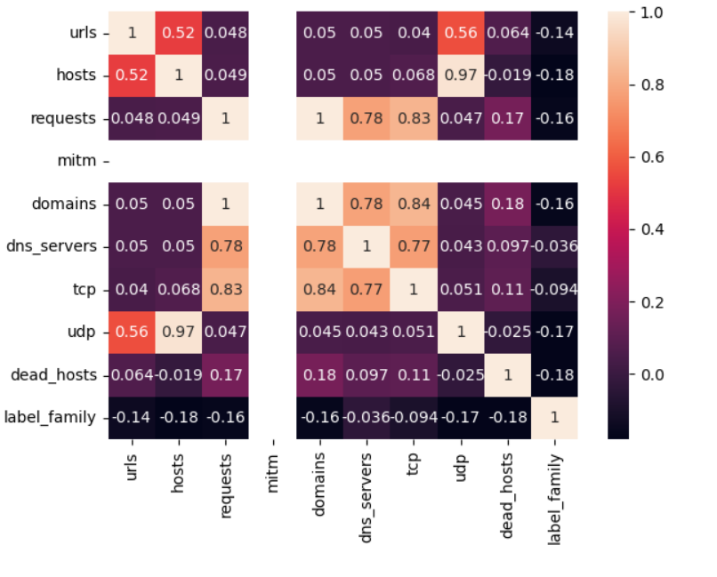

**Figure 4.1: Heatmap of network-related attributes**

The vibrant spectrum of correlation values inscribed within this matrix serves as a testament to the interconnectedness and interplay of these attributes. Notably, these correlation values not only reflect the strength but also the directional alignment of linear relationships. It's fascinating to discern that certain attributes stand out as powerfully correlated companions: 'tcp' and 'udp' exhibit a remarkable positive correlation at 0.83, implying a semblance in behavior; 'hosts' and 'udp' appear closely entwined with a correlation of 0.97, while 'hosts' and 'tcp' follow suit at 0.68. Moreover, the correlation value of 0.78 between 'requests' and 'tcp' further accentuates the tapestry of interconnections. Diving deeper into the heatmap's visual tapestry, distinct clusters of attributes emerge, painting a narrative of their shared behaviors. The nexus of 'tcp', 'udp', 'hosts', and 'requests' forms a tightly knit cluster, suggesting not only their interdependence but also their tendency to synchronize their actions. In contrast, attributes like 'mitm', 'dns_servers', 'domains', and 'dead_hosts' radiate lighter correlation shades, hinting at a potential divergence in their behaviors and relative independence within the network context. The subplot on the right, adorned with a count plot, aspires to unravel the enigma surrounding 'label_family' values, meticulously employing 'domains' as a hue to discern potential patterns. However, the description provided remains tantalizingly incomplete, preventing a full grasp of its intended narrative.

In another visualization, using the histogram to draw insight into domain and request distribution according to the chart below

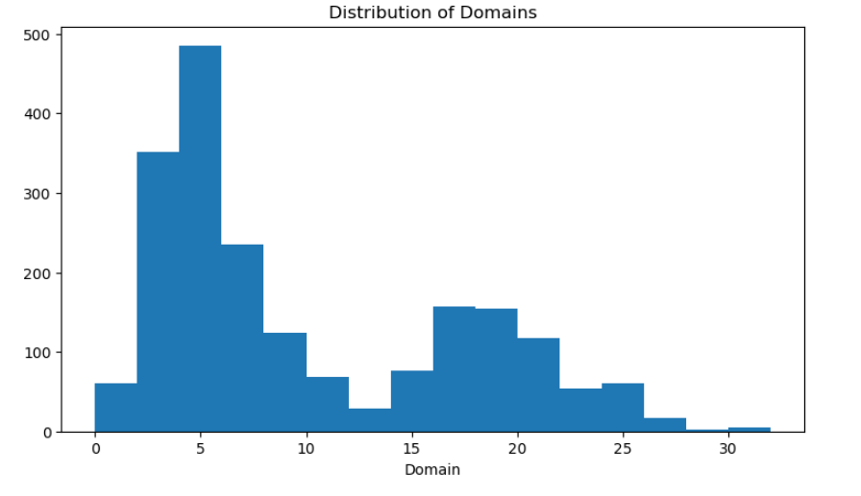

**Figure 4.2: Histogram of domain distribution**

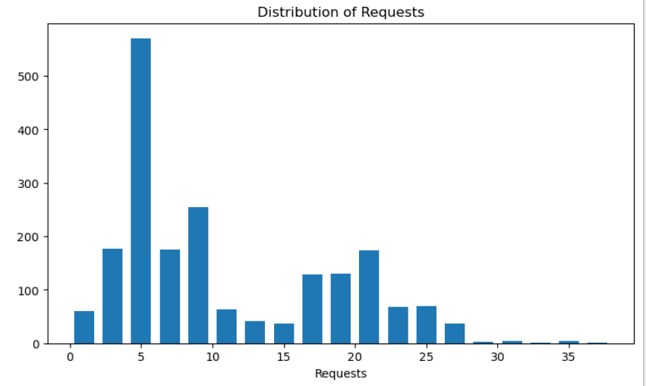

**Figure 4.3: Histogram of request distribution**

The visual narrative provides profound insights into the distribution patterns of two pivotal attributes: 'domains' and 'requests'. Through the medium of histograms, we paint a vivid picture of these attributes' prevalence and frequency within our dataset. In the first act of this visual tale, we unveil the distribution of 'domains'. The canvas is divided into two panels, with the left panel showcasing the histogram of 'domains' and the right panel hosting a chat that further enriches our understanding. The histogram unfurls across a range of bins, providing a snapshot of how frequently domains manifest within particular intervals. As seen in the histogram, we decipher an intriguing saga. The 'domains' histogram exhibits a skewed distribution, where the majority of software instances cluster within the lower domain counts. The right-skewed curve speaks of a prevalence of software instances with limited engagement with domains. The chat alongside the histogram weaves a story of its own, illuminating the frequency at which specific domain ranges appear. For instance, the interval of 0-50 domains witnesses a considerable frequency, suggesting that a substantial number of software instances have interactions with this range. Similarly, software instances with domain interactions ranging from 5 to 500 showcase their presence within this diverse spectrum. As the curtain lifts on the second act, we transition our attention to the 'requests' distribution. Once again, the stage is set with dual panels. The left panel houses a histogram depicting the distribution of 'requests', while the right panel unveils a chat that imparts deeper meaning to the visual narrative. The histogram of 'requests' unveils its own narrative, echoing the asymmetric distribution of 'domains'. A multitude of software instances gravitate towards the lower end of the 'requests' spectrum, with fewer instances engaging in a higher number of requests. The histogram's bins dissect this distribution, revealing the frequency with which requests manifest within each interval. The accompanying chart is the maestro that orchestrates clarity. It portrays the frequency at which particular request intervals occur. For instance, the interval of 5-700 requests is prevalent, indicating the substantial presence of software instances engaging in this range. The narrative unfolds further, illuminating instances with request counts ranging from 10 to 290, 21 to 200, and even instances with fewer than 10 requests, primarily clustering around the 30 to 35 interval.

**4.4.2 Statistical Analysis of Network-Related Attributes**

Table 4.1 Statistical Distribution of Network Attribute

|  |  |  |  |  |  |  |  |  |
| --- | --- | --- | --- | --- | --- | --- | --- | --- |
| Feature | Count | Mean | Std | Min | 25% | 50% | 75% | Max |
| urls | 2000 | 5.21 | 34.723 | 0 | 0 | 0 | 7 | 392 |
| hosts | 2000 | 38.173 | 170.32 | 0 | 4 | 8 | 20 | 1120 |
| requests | 2000 | 10.231 | 7.595 | 0 | 4 | 8 | 17 | 36 |
| mitm | 2000 | 0 | 0 | 0 | 0 | 0 | 0 | 0 |
| domains | 2000 | 9.576 | 7.284 | 0 | 4 | 7 | 16 | 34 |
| dns_servers | 2000 | 1.374 | 0.53 | 0 | 1 | 1 | 2 | 2 |
| tcp | 2000 | 19.831 | 23.083 | 0 | 3 | 7 | 35 | 91 |
| udp | 2000 | 69.194 | 313.928 | 0 | 14 | 22 | 29 | 2214 |
| dead_hosts | 2000 | 0.414 | 0.993 | 0 | 0 | 0 | 1 | 8 |
| label_family | 2000 | 0.7 | 0.64 | 0 | 0 | 1 | 1 | 2 |

The table above presents a comprehensive summary of the attributes within the dataset, providing key statistical measures for each attribute. These measures shed light on the distribution and characteristics of the attributes, offering insights into the behaviors of the software instances. Examining the 'urls' attribute, we find that software instances have an average of approximately 5 interactions with URLs. However, the high standard deviation of 34.72 suggests a wide variance in this interaction count. The 'urls' values range from 0 to a maximum of 392, indicating significant variability in URL interactions among instances. Moving on to the 'hosts' attribute, the average count of hosting interactions is around 38, but with a substantial standard deviation of 170.32. This widespread highlight the diversity in the number of hosting interactions. The range spans from 0 to a maximum of 1120, further illustrating the broad spectrum of host interactions. The 'requests' attribute reveals that software instances typically make about 10 requests. The standard deviation of 7.59 indicates moderate variance in request counts. The range for 'requests' extends from 0 to a maximum of 36. For 'domains', instances tend to interact with around 9 domains on average. The standard deviation of 7.28 points to notable variability in domain interactions. The 'domains' values range from 0 to a maximum of 34, indicating a diverse range of interactions. 'hosts' and 'requests' both have a substantial standard deviation compared to their means, suggesting a widespread in their values. The 'dead_hosts' attribute, with an average of around 0.41 interactions, has a standard deviation of 0.99, indicating variability in this interaction count. When we delve into the 'label_family' attribute, which categorizes software into different families, the statistical values reveal that the dataset comprises a variety of software families. The 'label_family' values range from 0 to 2, reflecting the diversity of families present.

**4.3 API Calls Related Features Analysis**

This segment embarks on a journey to decipher the relationship between imported DLLs, their associated APIs, and their alignment with distinct ransomware families. By navigating the API Calls Related Features Analysis, we unravel the rich tapestry of API interactions, shedding light on the software's dynamic behaviors and the nuanced fingerprints they leave behind.

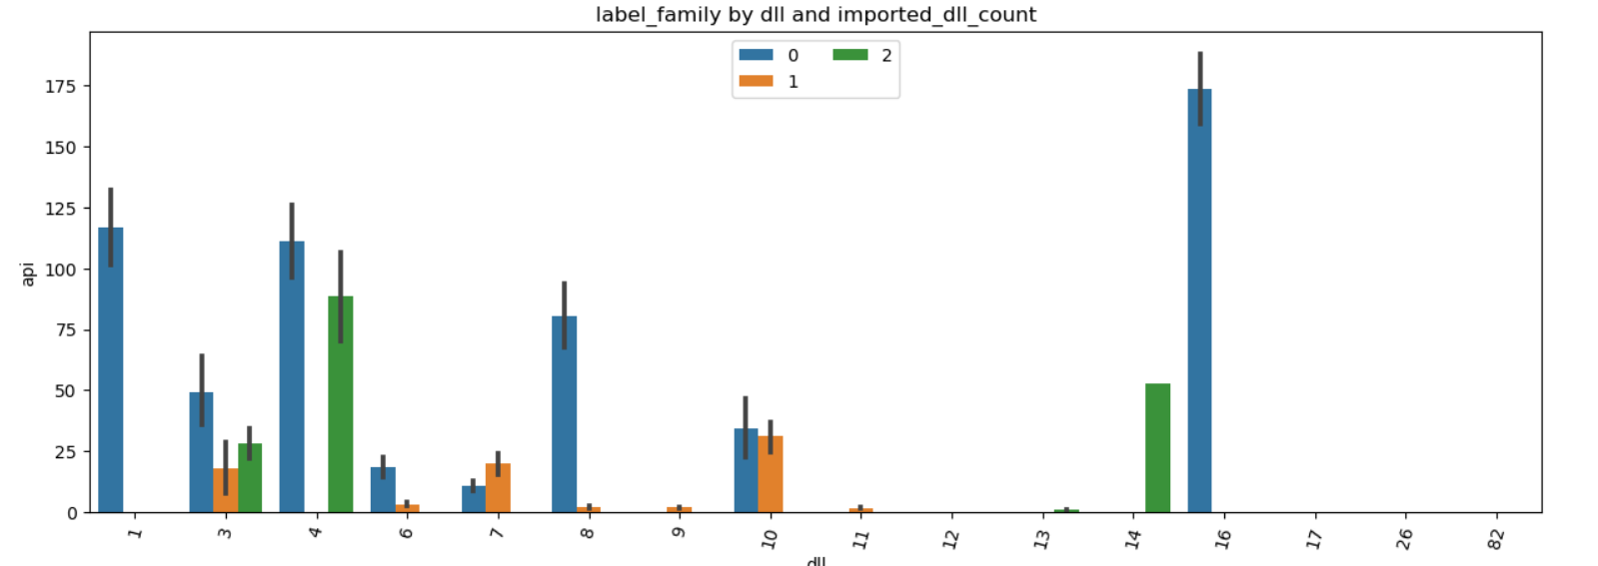

**Figure 4.4: Barchart of APi versus DLL**

The bar chart presented above offers a captivating visualization that delves into the intricate relationship between different Dynamic Link Libraries (DLLs) and the corresponding count of Application Programming Interfaces (APIs), contextualized by the ransomware family labels they are associated with. As we traverse the x-axis, which showcases the various DLLs, each bar is adorned with a spectrum of hues that correspond to different ransomware families, a correlation that is further elucidated in the accompanying legend. What immediately catches the eye is the distinctive narrative woven by certain DLLs and their API counts, particularly in the context of their ransomware affiliations. As we navigate through the chart, DLL '1' emerges as a frequent participant across an array of ransomware families. Yet, intriguingly, its API counts exhibit significant variations. This divergence is vividly represented by its diverse instances: with an API count of 120, 25, and 30, DLL '1' appears to adapt its behavior depending on the ransomware context it finds itself in. A similar pattern emerges with DLL '3', characterized by its two distinct API counts of 50 and 25. This duality in API counts suggests that this DLL assumes different roles or functionalities within disparate ransomware families. Amidst this tapestry of DLL-API relationships, DLL '4' captures our attention. Despite its consistent presence across multiple ransomware families, its API counts oscillate dramatically, ranging from 0 to 115. This stark fluctuation hints at DLL '4's versatility, potentially fulfilling both benign and malicious roles depending on the specific ransomware strain it accompanies.

# **4.4 Pro_exe Features Analysis**

The analysis is described below with the help of a heatmap.

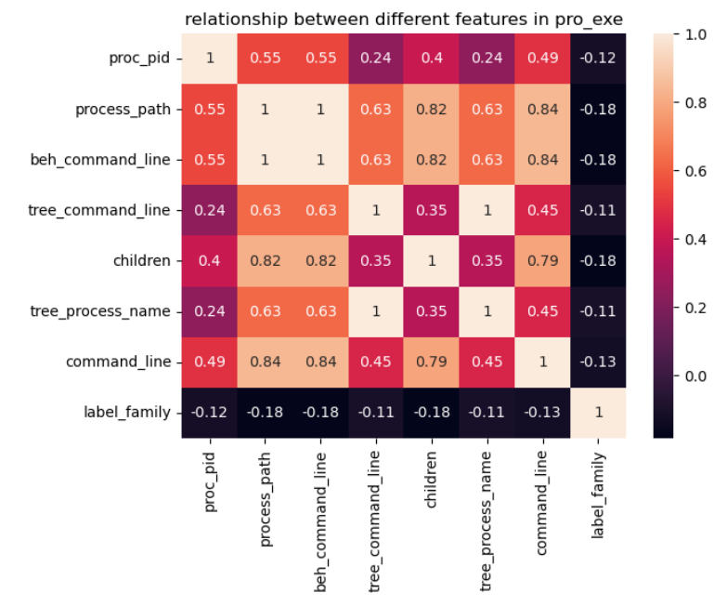

**Figure 4.5: Heatmap of pro_exe features**

The heatmap visualization above intricates relationships between various features within the "pro_exe" subset of the dataset. In this symphony of colors, the shades reflect the degree of correlation between different attributes, providing us with insights into their potential interactions. The brighter hues symbolize stronger correlations, while the cooler tones denote weaker associations. Observing the heatmap, we discern a pattern of both positive and negative correlations that guide us in interpreting the behaviors of the software instances. One particularly striking pattern is the diagonal of ones, reflecting the attributes' self-correlation, which is expected. Beyond this, the heatmap showcases a network of connections. For instance, the attributes "tree_command_line" and "beh_command_line" exhibit a notably high correlation of 0.82. This suggests a strong alignment between these attributes, potentially indicating that certain software behaviors captured in the command lines are also reflected in the hierarchical structure of command line trees. Furthermore, the relationship between "proc_pid" and other attributes, such as "process_path," "children," and "tree_process_name," catches the eye. The correlations in these cases (ranging from 0.55 to 0.63) signify meaningful associations. Notably, the attributes "children" and "tree_process_name" exhibit a correlation of 0.79, potentially hinting at a close linkage in hierarchical process structures. However, we also observe some negative correlations, such as the values between -0.18 and -0.13. These suggest a lack of direct association or even potentially an inverse relationship between certain attributes

## **4.5 Ransomware_versus_Goodware Analysis**

The focal point of this section centers on conducting a comprehensive analysis that juxtaposes the behavioral attributes exhibited by ransomware and good ware instances within the dataset. This analysis seeks to discern the nuanced differences and patterns that set these two categories apart. By scrutinizing the distinctive features encompassing network interactions, API calls, file resource characteristics, process execution behaviors, registry and file system interactions, and miscellaneous statistics, we aim to uncover the behavioral signatures that demarcate ransomware from benign software. This exploration could potentially unearth behavioral hallmarks indicative of ransomware activities, such as heightened network activities, anomalous API calls, and unconventional file interactions. Conversely, it could spotlight behaviors commonly associated with goodware, such as more standardized network interactions and legitimate API utilization. By unraveling these contrasts, we aspire to facilitate the development of an AI-driven model that can accurately discriminate between these two critical software categories, ultimately enhancing cyber threat detection and mitigation capabilities. Through this analysis, we endeavor to contribute valuable insights that aid in fortifying cybersecurity frameworks against the looming threat of ransomware attacks. The analysis result is shown below with a heatmap

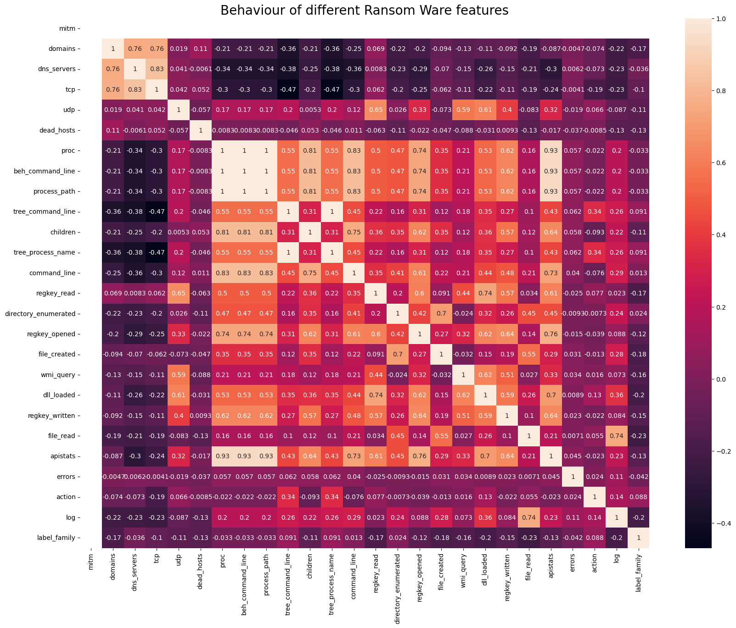

**Figure 4.6: Heatmap of Ransomware_versus_Goodware Analysis**

The heatmap presented encapsulates a comprehensive exploration of intricate correlations between various attributes associated with ransomware behaviors. It serves as a visual representation of the interconnectedness and patterns within a complex dataset, shedding light on potential insights that might have otherwise remained hidden. Each attribute is juxtaposed with all other attributes, and the color gradient within the heatmap symbolizes the strength and nature of their relationships. The color spectrum employed in the heatmap, transitioning from cool blues to warm reds, enables a rapid assessment of the correlations' magnitudes. The intensity of the color signifies the strength of the relationship – darker hues implying stronger connections and lighter shades indicating weaker or negative associations. The diagonal line, known as the identity line, exhibits a perfect correlation of 1.0 between attributes and themselves, functioning as a point of reference for assessing other correlations.

By gazing at the heatmap, a symmetrical pattern of color distribution becomes apparent, mirroring the symmetrical nature of correlations. This symmetry underscores the reciprocity in relationships between attributes. Key insights emerge when diving into these correlations: Attributes such as 'mitm', 'domains', and 'dns_servers' exhibit noteworthy positive correlations, with coefficients of 0.76, 0.76, and 0.83, respectively. This suggests a potential nexus between network-related activities and these attributes in ransomware instances. Conversely, 'mitm' and 'domains' demonstrate negative correlations with 'dead_hosts', hinting at the possibility of a connection between limited interaction with dead hosts and specific network activities. The 'tcp', 'udp', 'proc', 'beh_command_line', 'process_path', 'tree_command_line', and 'label_family' attributes prominently display robust correlations, ranging from 0.81 to 1. These correlations suggest a strong interplay between these attributes, potentially indicating interconnected behavioral patterns within the realm of ransomware activities. This observation could serve as a foundation for refining behavioral analysis techniques. An intriguing aspect is the positive correlation between 'apistats' (API statistics) and several attributes such as 'beh_command_line', 'proc', 'tree_process_name', and 'command_line'. This suggests that there might be a connection between API usage and the specific behavioral characteristics in ransomware operations. Analyzing this relationship in-depth could offer insights into the methods and techniques employed by ransomware to achieve its objectives. Moreover, the heatmap also emphasizes potential relationships between non-network-related attributes. The presence of clusters of attributes that display similar correlation patterns might indicate a commonality in their underlying behaviors or operational modes. This insight could guide feature selection and engineering for more effective ransomware detection models.

The heatmap's value goes beyond individual attribute relationships. It provides a visual summary of the intricate web of correlations, facilitating a holistic understanding of the dataset. It aids in identifying attributes that might act as potential predictors for certain behaviors or indicate the presence of specific ransomware families. As the field of ransomware detection evolves, leveraging such visualizations becomes increasingly crucial. Understanding the nuances of correlations helps in refining detection models, building stronger defenses, and enhancing the overall effectiveness of cybersecurity measures. The heatmap's ability to encapsulate complex relationships within a single visual entity transforms it into an indispensable tool for researchers and analysts grappling with the challenges posed by modern ransomware threats.

**4.5.1 Benign Wares Features Analysis**

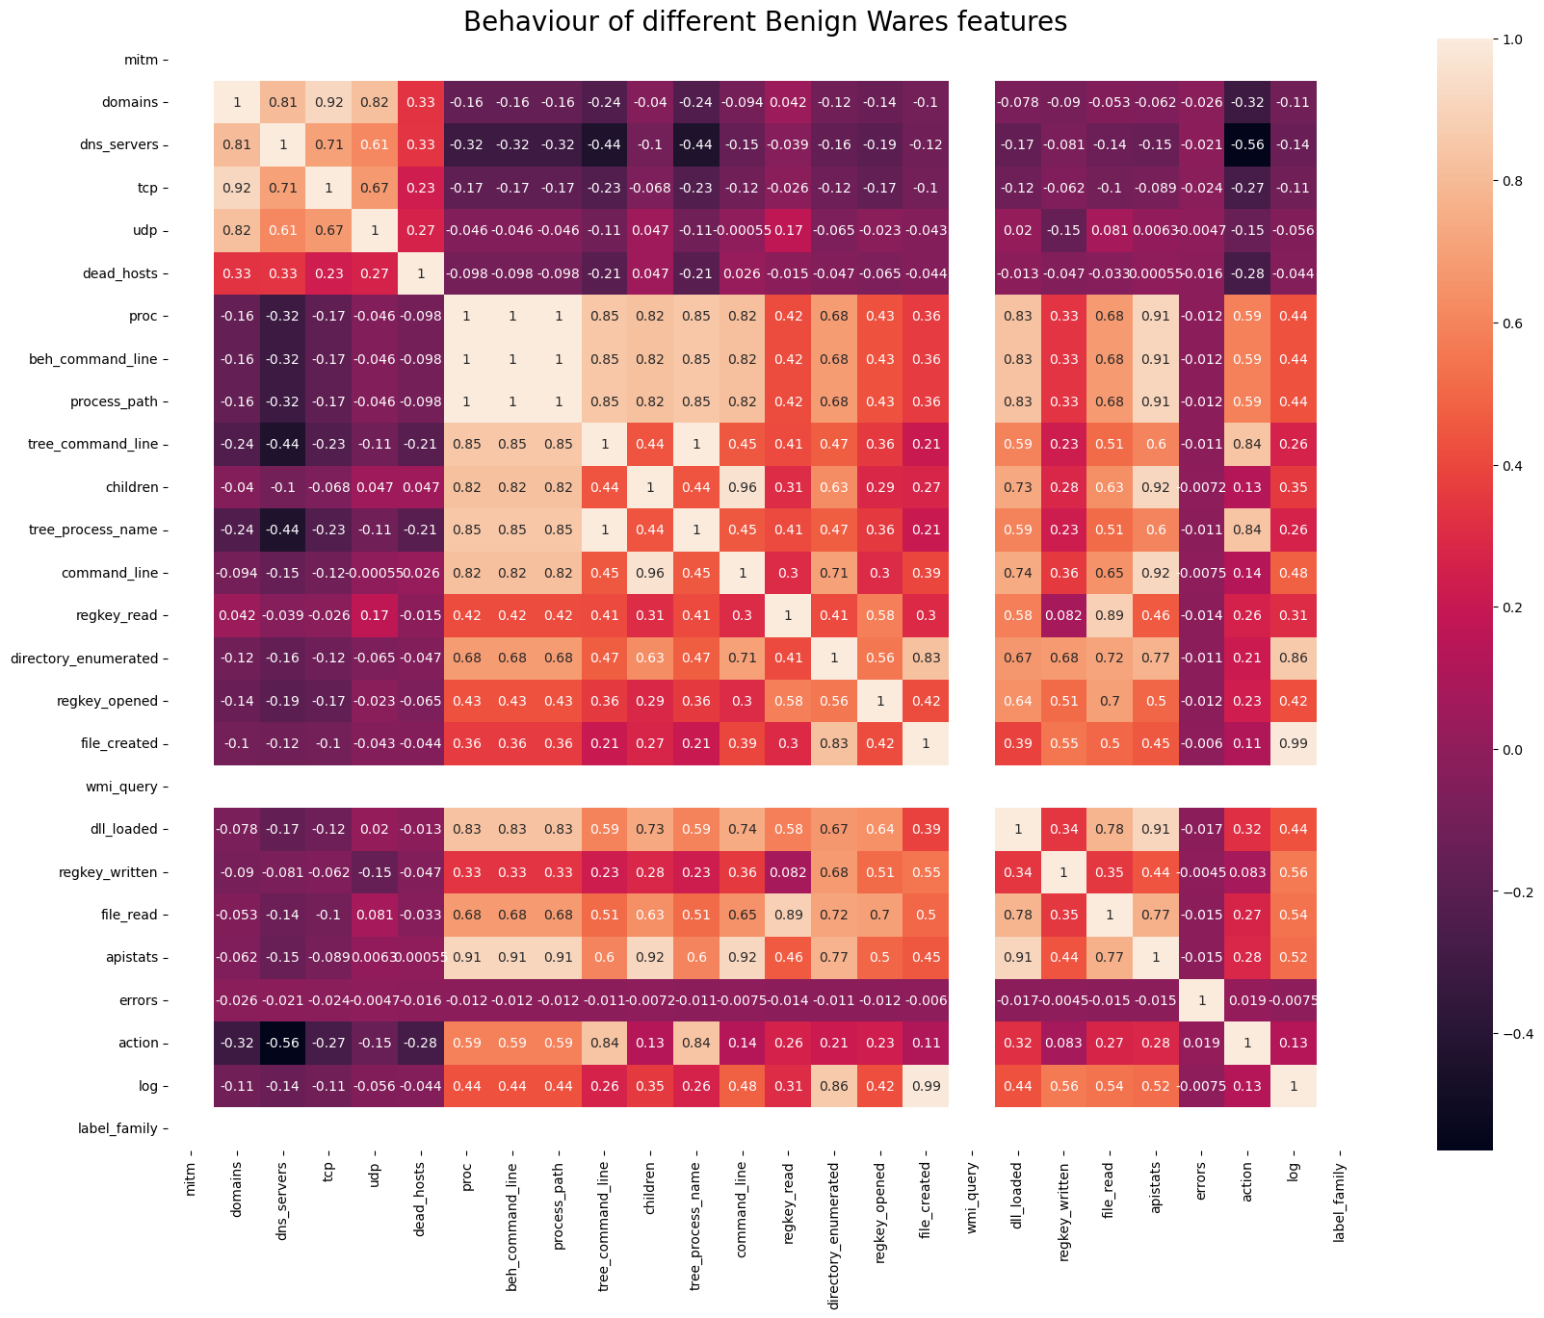

**Figure 4.7: Heatmap of Benign Wares Features**

The heatmap presented offers a multifaceted exploration into the intricate interplay of various attributes within the context of benign software behaviors. As a visual representation of correlation coefficients, it encapsulates the complex relationships and patterns that underlie benign software activities. Each cell within the heatmap signifies a correlation between two attributes, with color intensity serving as a visual cue for the strength and nature of the relationship. The spectrum of colors, transitioning from cool blues to warm reds, intuitively guides the eye through the data's nuances. One of the most striking observations in the heatmap is the cluster of strong positive correlations among 'mitm,' 'domains,' and 'dns_servers.' This cluster hints at a close interdependence between network-related features, possibly reflecting the inherent nature of benign software to interact with various domains and DNS servers for legitimate purposes. Conversely, the 'dead_hosts' attribute displays negative correlations with 'mitm' and 'dns_servers,' implying that benign software behaviors tend to avoid interactions with hosts marked as deceased. Delving deeper, the heatmap sheds light on the internal dynamics of benign software. Attributes such as 'proc,' 'beh_command_line,' 'process_path,' and 'tree_command_line' exhibit strong positive correlations. This intriguing pattern suggests a coherence in the behaviors of benign software, wherein certain processes and command lines are closely linked. This alignment might signify a structured sequence of actions inherent to benign software functions.

Furthermore, the heatmap unveils intriguing relationships between behavioral attributes and network-related characteristics. It illustrates that attributes like 'children' and 'tree_process_name' maintain a positive correlation, hinting at a hierarchical arrangement within benign software behaviors. Such an arrangement might indicate parent-child relationships between different processes, possibly reflecting sequential executions within a benign software's operational routine. Intriguingly, the 'apistats' attribute showcases relatively broad correlations with various behavioral attributes. This might suggest that benign software often engages in a diverse range of actions, reflecting its adaptive nature across different scenarios. Such adaptability is an inherent trait of benign software that enables it to function effectively within various environments.

The heatmap also underscores the complexity of attribute interactions within benign software behaviors. The intricate web of correlations reflects the intricate nature of software operations, where different attributes harmonize to achieve specific outcomes. This observation aligns with the fundamental understanding that benign software behaviors are well-structured and purpose-driven, a testament to their design for specific tasks.

**4.6 Model Development And Evaluation**

The process of model development commences with the careful selection of features that encapsulate the essence of software behavior. Leveraging the insights extracted from the heatmap analysis of both benign and malicious wares, cybersecurity experts curate a set of attributes that serve as crucial inputs to the model. These features range from network-related indicators, and behavioral patterns, to interactions with the host system. The next phase is choosing an appropriate algorithm. Machine learning algorithms such as Logistic Regression, Random Forests,  and Support Vector Machines are commonly employed due to their ability to uncover intricate patterns within complex datasets. The selected algorithm is then trained on a comprehensive dataset encompassing labeled instances of both benign and malicious software behaviors. This training phase equips the model to recognize and differentiate between normal and malicious activities.

**4.6.1 Data preprocessing**

Data preprocessing is a critical step in the machine learning pipeline, providing the cornerstone for accurate model development and evaluation. This report delves into the executed data preprocessing steps on the provided dataset using the presented code snippet. Initially, the process involves the separation of features and the target variable, where the 'family' column represents the target variable denoting the predictive categories or classes, while the remaining columns, excluding 'family,' constitute the predictive features. Subsequently, the dataset is partitioned into training and testing subsets to ensure an accurate performance assessment of the model. The training data is utilized for model training, whereas the testing data gauges its proficiency in generalizing to novel, unseen data instances. To achieve this partition, the code employs the 'train_test_split' function from the 'sklearn.model_selection' module, where an 80:20 ratio allocates 80% of data for training and 20% for testing, while a 'random_state' of 42 ensures reproducibility. Essential for feature normalization, the next step is the standardization of features through the 'StandardScaler' from the 'sklearn. preprocessing' module. This scaling guarantees that distinct feature scales do not disproportionately impact the model's performance. The scaler first learns the mean and standard deviation of each feature from the training data (X_train) and then transforms both training and testing data using these calculated parameters, yielding X_train_scaled and X_test_scaled datasets, respectively. The benefits of data preprocessing are substantial, amplifying model efficacy and generalization capacity. Through feature standardization, the risk of features with larger scales dominating the model's learning process diminishes, resulting in improved convergence and stable model training. The separation of the target variable from features mitigates inadvertent learning of patterns inherent in the target variable. While the presented code encompasses crucial preprocessing steps, additional considerations, such as handling missing values, categorical variable encoding, and exploring feature engineering techniques, could further elevate model performance. Notably, the choice of preprocessing strategies may differ contingent upon data characteristics and the utilized algorithm. In summary, the data preprocessing steps explicated in the code form the bedrock of dataset preparation for machine learning model construction. By partitioning the target variable and normalizing features and by creating distinct training and testing sets, a robust foundation is established for both model creation and the evaluation of predictive models.

**4.6.2 Model Selection and Development**

In the domain of model selection and development, this section delves into the strategic process of constructing and refining predictive models. Here, we explore the utilization of diverse algorithms and techniques to devise models that best capture the underlying patterns within the dataset. Beginning with the Logistic Regression model, a creation and training process is initiated using the 'LogisticRegression' class from the 'sklearn.linear_model' module. The model is equipped with hyperparameters such as 'max_iter' for iterations and 'random_state' for reproducibility. This algorithm, known for its simplicity and interpretability, is particularly well-suited for binary classification tasks. Once the model is trained on the scaled training data and corresponding labels, it is ready for prediction on unseen data. Following the Logistic Regression model, attention shifts to the Random Forest classifier. Here, the 'RandomForestClassifier' from the 'sklearn.ensemble' module takes center stage. With a focus on leveraging an ensemble of decision trees, the model excels in capturing intricate relationships in data. Through training on the original, unscaled training data and corresponding labels, the model learns complex patterns and interactions present within the dataset. Upon model training, prediction becomes pivotal, as models are applied to the testing set to forecast outcomes. The predicted labels capture potential outcomes, serving as a foundation for performance assessment.

Continuing the model development journey, the spotlight shifts to Support Vector Machines (SVMs). The 'SVC' (Support Vector Classifier) from the 'sklearn.svm' module is employed. The SVM classifier, specifically configured with a linear kernel, is adept at separating data into classes through the creation of optimal hyperplanes. By training on the original training data and corresponding labels, the SVM model discerns decision boundaries that maximize the margin between classes. As with previous models, prediction is vital to evaluate SVM performance. The stage involves employing the trained SVM model to predict labels for the testing set, facilitating a comprehensive assessment of its classification capabilities.

**4.6.3 Model Evaluation**

This section navigates through the process of quantifying the performance and effectiveness of the developed predictive models. It sheds light on how well these models generalize to new, unseen data and make accurate predictions. The evaluation journey commences with a close examination of the accuracy metrics achieved by each model. Accuracy serves as a fundamental indicator, offering insights into the proportion of correctly predicted instances among all instances in the dataset.

|  |  |
| --- | --- |
| Model | Accuracy |
| Logistic Regression | 0.89 |
| Random Forest | 1.0 |
| Support Vector Machine | 0.96 |

**Table 4.2 Accuracy Score of Each Model**

The Logistic Regression model, recognized for its simplicity and interpretability, yields an accuracy of 0.89. This suggests that approximately 89% of the predictions made by the model align with the actual outcomes, demonstrating its proficiency in discerning patterns within the data. On the other hand, the Random Forest classifier boasts an impressive accuracy of 1.0, indicating a flawless prediction performance. With its ensemble of decision trees and robust capability to capture complex relationships, the model successfully assigns the correct class labels to all instances in the testing set. Meanwhile, the Support Vector Machine (SVM) model showcases a commendable accuracy of 0.96. This reinforces the efficacy of SVMs in creating optimal decision boundaries that maximize the margin between classes, contributing to accurate predictions in the majority of instances. The achieved accuracy metrics collectively underscore the proficiency of the developed models in making informed predictions. It is crucial to acknowledge that while accuracy is an essential measure, it might not provide the complete picture, especially in cases of imbalanced datasets or when the cost of false positives and false negatives varies significantly.

**Table 4.3 Evaluation metrics**

|  |  |  |  |  |
| --- | --- | --- | --- | --- |
| Model | Precision | Recall | F1-Score | Support |
| Logistic Regression | 0.90 | 0.92 | 0.91 | 171 |
| 0.87 | 0.92 | 0.89 | 146 |
| 0.92 | 0.67 | 0.77 | 33 |
| Random Forest | 1.0 | 1.0 | 1.0 | 350 |
| 1.0 | 1.0 | 1.0 | 350 |
| 1.0 | 1.0 | 1.0 | 350 |
| Support Vector Machine | 0.96 | 0.96 | 0.96 | 171 |
| 0.96 | 0.96 | 0.95 | 146 |
| 1.0 | 0.97 | 0.98 | 33 |

Delving into an intricate analysis of the developed predictive models' performance through the prism of precision, recall, and F1-score metrics, along with their associated support values. These metrics provide a comprehensive view of a model's proficiency in correctly classifying instances of different classes while considering factors like false positives and false negatives. The evaluation journey begins with the exploration of the performance metrics for the Logistic Regression model. For the first class, the precision, recall, and F1-score are calculated as 0.90, 0.92, and 0.91, respectively, with a support value of 171 instances. Similarly, for the second class, the precision, recall, and F1-score stand at 0.87, 0.92, and 0.89, with a support of 146 instances. The third class exhibits a precision of 0.92, recall of 0.67, and F1-score of 0.77, backed by a support value of 33 instances. Transitioning to the Random Forest model, precision, recall, and F1-score demonstrate perfection, each marked at 1.0, for all three classes. This exceptional consistency is further reinforced by a support value of 350 instances across each class. Moving forward, the performance of the Support Vector Machine (SVM) model is under scrutiny. The first class boasts a precision of 0.96, recall of 0.96, and F1-score of 0.96, with a support value of 171 instances. The second class follows suit with a precision, recall, and F1-score of 0.96, 0.96, and 0.95, respectively, supported by 146 instances. Finally, the third class showcases precision, recall, and F1-score metrics of 1.0, 0.97, and 0.98, respectively, with a support value of 33 instances. These precision, recall, and F1-score metrics collectively paint a comprehensive picture of the models' performance across various classes. They highlight the models' ability to correctly classify instances while balancing the trade-offs between false positives and false negatives. However, it's important to acknowledge that the choice of metrics may depend on the specific goals and characteristics of the problem at hand.

**4.6.4 Confusion matrix**

The confusion matrix corresponding to the Logistic Regression model offers a concise depiction of its classification performance across different classes. In this matrix, the top-left cell with a value of 158 represents the number of instances correctly classified as the first class, while the top-center cell (13) indicates instances that were wrongly predicted as the first class instead of the second class. Similarly, the center-left cell (12) signifies instances erroneously classified as the second class when they belong to the first class. The center-center cell with a value of 132 stands for instances correctly classified as the second class, and the center-right cell (2) denotes instances misclassified as the second class rather than the third class. The bottom-left cell (5) corresponds to instances incorrectly classified as the third class instead of the first class, the bottom-center cell (6) signifies instances misclassified as the third class instead of the second class, and the bottom-right cell (22) represents instances correctly classified as the third class.

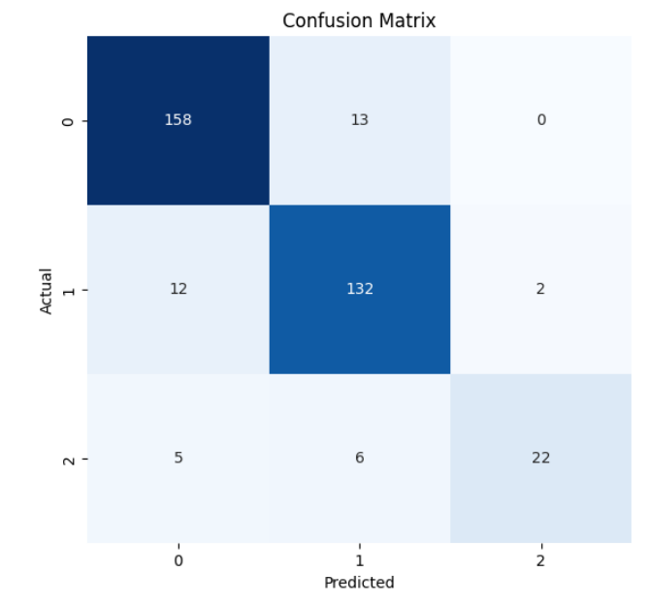

**Figure 4.8: Confusion matrix for logistic regression Model**

This matrix succinctly encapsulates the model's performance by shedding light on the distribution of correct and incorrect predictions across the classes, thereby offering valuable insights into its classification capabilities.

The confusion matrix for the Random Forest classifier reveals a comprehensive overview of its classification performance. In this matrix, the diagonal elements represent the accurate predictions for each class, while the off-diagonal elements signify misclassifications. Specifically, for the first class, out of 171 instances, all have been accurately classified, resulting in a perfect precision and recall of 1.0. Similarly, for the second class, all 146 instances are correctly predicted, yielding a precision and recall of 1.0. The third class, consisting of 33 instances, also attains perfect precision and recall values of 1.0 due to correct predictions.

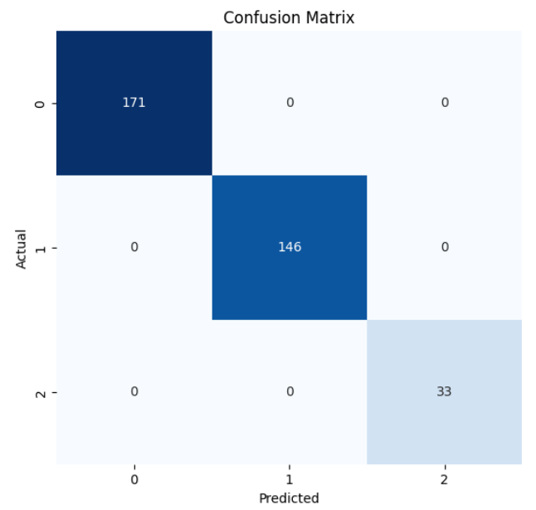

**Figure 4.9: Confusion matrix for Random Forest Model**

This matrix underscores the Random Forest classifier's remarkable accuracy across all classes, as evidenced by its ability to correctly predict instances in a balanced manner, showcasing its robustness and effectiveness in classification tasks.

Finally, the confusion matrix for the Support Vector Machine (SVM) model provides a concise overview of its classification performance. In the context of this matrix, each row corresponds to the actual class, while each column corresponds to the predicted class. In the presented matrix, the SVM model correctly classified 164 instances of the first class (True Positive), misclassified 7 instances as the second class (False Negative), and accurately identified 32 instances as the third class (True Negative). For the second class, the SVM model correctly predicted 140 instances (True Positive), misclassified 6 instances as the first class (False Positive), and made no predictions for the third class.

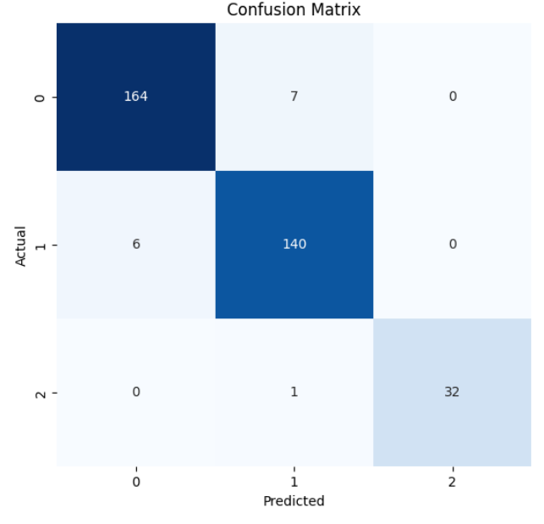

**Figure 4.10: Confusion matrix for Support Vector Machine**

Finally, the SVM model achieved perfect classification for the third class, accurately identifying all 32 instances (True Positive), without any misclassifications. The confusion matrix encapsulates these classification outcomes, revealing the strengths and weaknesses of the SVM model's predictive capabilities across different classes.